MollyBea Williams. Alyssa Barthel, Brooke Geisler
Fractions RNP 1
Grade: 5th
Standard/Benchmark:
5.1.3.3 Estimate sums and differences of decimals and fractions to assess the reasonableness of results.

Objectives:
- Students will understand how to make estimations that involve fractions.
Materials:
- Manipulative circles
- Worksheets
- Pencils
Launch:
Class, I have a friend and he has a problem that he wants you to think about. His name is Alex. Here is what he told me. Alex used 1/3 cup of flour in one recipe and 1/4 cup of flour in another recipe. Together did he use more than 1/2 cup of flour?(story problem taken from the RNP website).
Explore
- Today we are going to work with fractions and do some estimating. Can anyone tell me what it means to make an estimation?
- Hand out fraction manipulatives.
- Ask students to list five fractions that are greater than ½. they can use the manipulatives to help them visualize.
- Ok, Can you tell me how you decided that those fractions are larger than ½?
- Present this story to the students: William ate 1/4 of a pizza for dinner. The next morning he ate a piece that equaled 1/8 of the pizza. How much of a pizza did he eat? Make an estimate.
- Have students work in groups to estimate an answer to this problem.
- Explain that you don’t want the exact answer, but just an estimate. Ask students to imagine 1/4 of a pizza and 1/8 of a pizza. Did William eat more or less than 1/2 of a pizza? Have students to explain their responses by referring to their mental images for 1/4 and 1/8 .
- On the doc cam represent the problem with the manipulatives to show that he ate less than ½ of the pizza.
- Provide added practice by estimating these sums. In each case,estimate as >1/2 or < 1/2, and >1 or <1.
1/8 + 1/4=? 3/6 +1/4=? 4/6+1/2=?
- Allow students time to make these estimations in their groups. Then have the students write their estimations on the board.
- Ask students to Explain their reasoning. Talk about how they came up with their estimation.
Summarize:
In today's lesson, we learned a bit more about fractions. We learned how to estimate the sum of two fractions.
Apply:
To apply this, the students can take home and complete the worksheet.
Resources
I took this lesson and worksheet from the Rational Number Project. The parts that are italicized are taken work for word from the RNP.
Rational Number Project. Initial Fraction Ideas: Lesson 19. Retrieved From
http://www.facebook.com/l.php?u=http%3A%2F%2Fwww.cehd.umn.edu%2Fci%2Frationalnumberproject%2FRNP1-09%2FRNP1-09_19.pdf&h=_AQHabqfK&s=1
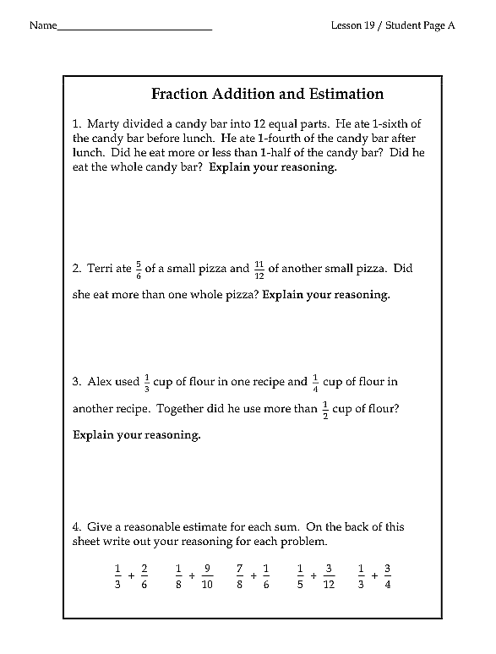
Taken From
Rational Number Project. Initial Fraction Ideas: Lesson 19. Retrieved From
http://www.facebook.com/l.php?u=http%3A%2F%2Fwww.cehd.umn.edu%2Fci%2Frationalnumberproject%2FRNP1-09%2FRNP1-09_19.pdf&h=_AQHabqfK&s=1

